Project Design Phase-II
Technology Stack (Architecture & Stack)

Date | 08 October 2026
Team ID | 9100Quadra
Project Name | Auto Ticket Classification Using ServiceNow Flow Designer
Maximum Marks | 4 Marks

Technical Architecture:
The deliverable includes the architectural diagram below and the information as per Table-1 and Table-2.
Example: Automatic classification of school IT incidents using ServiceNow Flow Designer
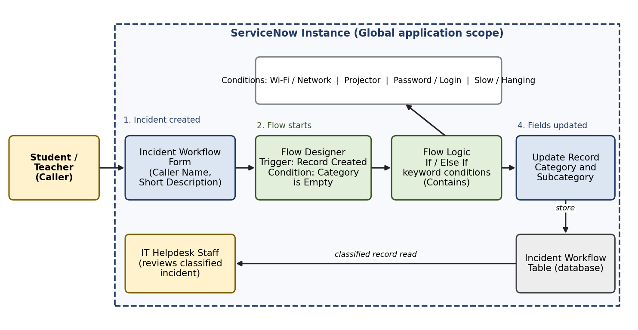
Table-1 : Components & Technologies:
S.No | Component | Description | Technology
1. | User Interface | Incident form used by callers and list view used by helpdesk staff | ServiceNow platform UI (Next Experience)
2. | Application Logic-1 | Trigger: Record Created on the Incident Workflow table with condition Category is Empty | ServiceNow Flow Designer
3. | Application Logic-2 | If / Else If conditions using data pills (Short Description Contains keyword) | Flow Designer - Flow Logic
4. | Application Logic-3 | Update Record action sets Category and Subcategory | Flow Designer - Actions
5. | Database | Table storing ticket records with Caller Name, Short Description, Category, Subcategory | ServiceNow platform database (custom table)
6. | Cloud Database | Not applicable - the ServiceNow instance hosts the data | -
7. | File Storage | Update set exported as an XML file | Local file system
8. | External API-1 | Not used | -
9. | External API-2 | Not used | -
10. | Machine Learning Model | Not used; classification is rule / keyword based | -
11. | Infrastructure (Server / Cloud) | Application deployed in the Global scope of a ServiceNow instance | ServiceNow cloud instance

Table-2: Application Characteristics:
S.No | Characteristics | Description | Technology
1. | Open-Source Frameworks | None; the solution uses native ServiceNow no-code features | Flow Designer
2. | Security Implementations | Role-based access to incident records and the flow; only authorised users modify ticket data | ServiceNow roles and ACLs
3. | Scalable Architecture | New keywords and categories are added as further conditions in the flow | Flow Designer
4. | Availability | Runs on the ServiceNow cloud instance | ServiceNow instance
5. | Performance | Flow runs automatically at record creation; no manual step is needed | Flow Designer trigger

References:
https://docs.servicenow.com (Flow Designer, Update Sets)

